Medfield Parks & Recreation

2020 Summer Camp Permit Addendum
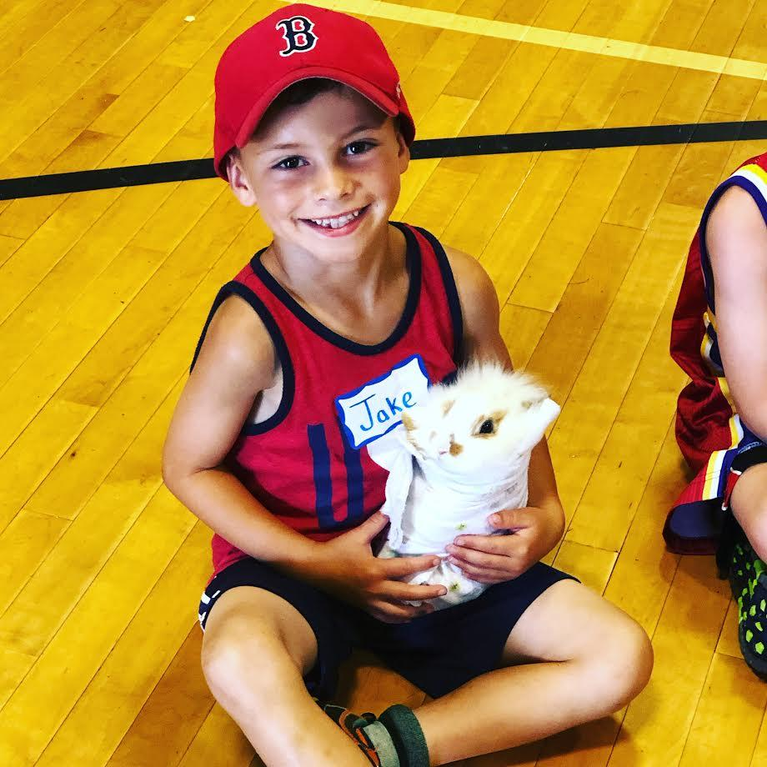
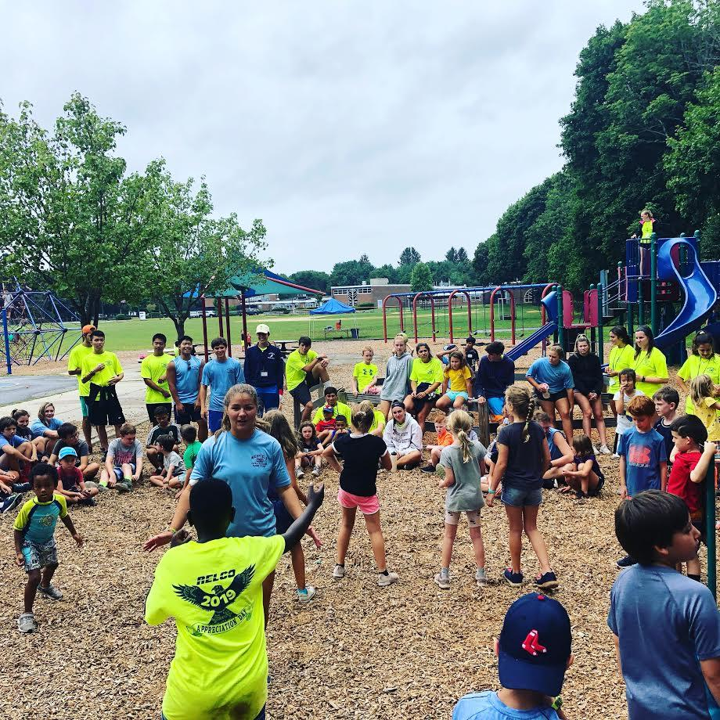
This is the addendum to the 2020 Medfield Parks & Recreation summer camp permit, which had previously been submitted. This will go into detail about the updated regulations put in place by the Massachusetts Department of Early Education and Care as a result of the COVID-19 pandemic.
This document will outline updates that we will be following and will be submitted to the Medfield Board of Health for approval. Whenever noted in the regulations, we will always go with the best possible practices to continue to provide a safe and healthy environment for campers and staff.

- RECREATIONAL CAMPS
- General Guidance for Recreational Camps and Programs
- The guidelines for phase 2 call for a restriction on group sizes to no more than 12 people, which includes staff. With this, we would operate with 3 staff and 9 campers per group during the initial phases.
- No visitors permitted at camp. We will do a drive-thru system for drop off and pickup during the camp season.
- We already follow the guideline about state residency being a requirement for campers and staff at our camps. Additionally, we will only allow Medfield residents to attend camp this summer.
- We already comply with 105 MR 430 Minimum Standards for Recreation Camps for Children: Sanitary Code Chapter IV, and we have for several years.
- Planning for Recreational Camps and Programs
- We will provide a copy of the updated plans to our staff during orientation and have available for viewing throughout the summer. We will be doing a detailed training of the new regulations that will apply to camps this summer.

2. We will have a detailed plan in place to address cleaning, disinfecting, sanitizing and frequency.
a. We will be having two staff per camp (four staff total) who will have the responsibility to be a “cleaning team” each week. This will include monitoring high touch areas (bathrooms, doors, etc) and being ready to clean those after uses.
b. We will do a deep clean of facilities before the start of camp, including tables, chairs and other areas of the Pfaff Center, the playground at Dale Street School and any other spaces that will be used.
c. We will have a daily cleaning schedule that will include before, during and after camp.
d. Staff inside each cohort will be responsible for cleaning and disinfecting materials they use as part of their camp day.
e. Campers will be required to wash and sanitize hands before and after each activity, snack and lunch. To limit the traffic coming inside either the Pfaff Center or Dale Street School, we will have multiple portable cleaning stations around camp for use by campers and staff.

- The plan we will have for handling sick children and/or staff during the camp season:
  - We will have camp nurses on staff this summer to help with evaluating anyone that is showing symptoms of COVID-19
  - We will have a room marked off in both the Pfaff Center and Dale Street School where anyone showing symptoms of COVID-19 would be brought to, with the goal to limit their exposure to the camp.
  - Discharging of sick campers and/or staff – once it has been determined that someone needs to be excused from camp, either a parent or guardian will be contacted to come pickup their child. For staff under 18, a parent/guardian will be contacted.
  - If we have a potential case of COVID-19 at camp, Kevin Ryder will immediately be in touch with Bridget Sweet, the Board of Health agent, who will follow through the proper channels.
  - Sick leave for staff will be monitored this year. If any staff is showing multiple symptoms or is running a fever, they are asked to not report to work. They will be asked to monitor their temperature and symptoms while home and report back to the camp. These symptoms include a frequent cough, sneezing, fever, difficulty breathing, chills, muscle pain, headache, sore throat, or recent loss of taste or smell, or if they or someone they live with has been diagnosed with COVID-19. The staff member responsible for responding to all COVID-19 concerns will be Kevin Ryder.
  - Anyone with a temperature above 100. 4 is asked to stay home (campers and staff).

- CAMP CLOSINGS
This will be a major change for our summer camps this season. Due to lack of adequate space as determined by the guidelines, we will be forced to close camp if there is a predicted rainstorm for any day camp is scheduled. We will do our best to notify families as soon as a cancellation is made, via the email system on www.MedfieldRec.com and posting on the front page of our site. We will still have staff at the Pfaff to greet anyone that does arrive to notify them of the camp being closed.
If we get inclement weather during the camp day and it is not expected to last for an extended period of time, we will gather the groups inside the Pfaff Center (Discovery Camp) and Dale Street School (Adventure Camp), keeping a 10-foot physical distance from each group.
If we get weather that is forecast to last longer then the end of the camp day, we will communicate out to parents about early pickup and what to do.

- Proper sharing of communication and guidelines with parents
  - For when parents arrive at camp with their child:
    - We will have a laminated checklist to ask the parents about how their child is feeling and what they have been exposed to within the past 24 hours. They will give verbal answers to the checklist.
    - Parents will need to have taken their child’s temperature prior to camp and need to share that with staff at drop off. Temperature will be noted for each child.
    - Parents will confirm all emergency contact information for their child, including the person that will be picking their child up at the end of the day.
    - We will have posted COVID-19 information at our camp sites, links will be provided on our web site and in all email communication with parents.
    - All our policies, especially those related to COVID-19, will be shared with parents and staff. This will include, but not be limited to, email, posting on our Web site and available in printed form at camp.
  - Drop off and pick up procedures:
    - We will institute a contactless, drive up policy for drop off in the morning. Our attempt will be to do this in staggered time slots, with each group/cohort having a 10-minute window to drop off their child.
    - We will do the same for pickup, with a 10-minute window to pickup your child.
    - Our attempt here is to keep the cohorts together and minimize mingling of kids from different cohorts.
    - We will make every attempt to accept late drop offs, but cannot guarantee a child dropped off after their allotted time window would be allowed into camp.

- Preparing for Recreational Camp
  - “Camp in a Box” 🡪 There will be a bin for each group during camp that will have all the materials they will need for each day. This will include medical supplies, cleaning and sanitizing supplies, materials for any scheduled activities and materials for down-time activities. Each group also will have a dedicated ball bag.
    - Staff will be responsible for cleaning and sanitizing any items that would be shared during an activity. This will include before and after each activity.
  - Preparation and storing of cleaning supplies 🡪 We have always had rules in place for this. We will continue to have preparation and storage inside the main office at the Pfaff Center.
  - We will have physical distance spacing inside both the Pfaff Center and Dale Street School. We will mark off areas with moveable walls, tape or other ways to mark spots that groups can use during the day.
    - Additionally, activities will be held in pre-determined areas for groups, led by specialists.
  - Staffing – we have always far exceeded the minimum requirements called for by the state when it comes to summer camp staff. This will not be different this summer. As already stated, we will have three staff per group with nine campers (for the 12 total). We also will have dedicated staff for cleaning each day, and these duties will be rotated throughout the staff each week.
    - Health Care Supervisors – we’ve always had two for our camps, one with Discovery and one with Adventure. This will continue under the new guidance from the state.
  - Storage of belongings:
    - Everyone will be encouraged to only bring the absolute necessities to camp each day. We won’t have adequate space to store personal belongings
    - We will have campers and staff keep their belongings – preferably lunch bags – in a dedicated space inside the Pfaff Center or Dale Street School.
      - Areas will be marked out with tape and clearly marked for each group. It will remain the same location everyday of the specified week.
  - To provide proper ventilation – which helps prevent a spread of the virus – we have decided to not install any wall air conditioning units this summer. In its place, we will keep doors and windows open to keep air flow moving throughout the building. Additionally, as many activities as possible will be held outside, as space allows.
    - We will have daily scheduled indoor classes, though, to break up the day.
    - We will work with the Facilities Director and the Water Department to ensure that water is safe for use and to minimize any Legionnaires or other diseases associated with water.
- Additional Strategies to Reduce the Risk of Transmission for Recreational Camps
  - Groups will not be combined during camp. The groups will always follow physical distancing throughout the day, especially when they come into common areas.
    - Groups will have specified areas for snack and lunch
    - The same three counselors will be with their group for the entire week
      - Should someone become sick and not be able to continue at camp, we will move a staff member from another area (like a cleaner) into that group since they would not have been exposed to any groups.
  - Supervision of the camps will be provided by Kevin Ryder and Jacqui Conley throughout the day. Both will be assigned a specific camp to oversee and be the point of contact for the staff.
    - Every group will have a walkie-talkie in which to be in contact with each other if help is ever needed. This will provide direct communication to Kevin, Jacqui and the office throughout the day.
  - Staff meetings will be held either remotely or in a physically-distance way.
  - There will be a scheduled use of any common areas throughout the day. Camps will follow a schedule so that a doubling up of common areas is prevented as much as possible.
    - Common areas will be cleaned/sanitized before and after uses.
      - EX: Playground 🡪 We will do a power washing of the playground before the start of camp. Then we will do a sanitizing and cleaning of the playground at the start of each camp day; before and after each usage; and at the end of the day.
        - Similar protocols will be followed for any other communal areas.
  - Isolation room -> in case the need arises to have to isolate someone at camp, we will have them brought to a specified room inside the Pfaff Center where they will be able to be alone. We also will have a similar room inside the Dale Street School.

